3.5 inch HD-TFT Display shield for Raspberry pi 2B/B+ With Keyboards and Remote IR
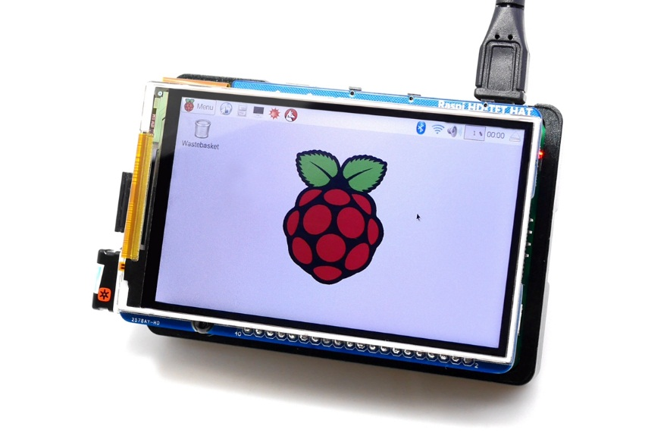

Features:
- Demensions：85mm×56.5mm;
- Resolution: 800 x 480, 3.5 inch;
- 267ppi High PPI display screen;
- 11ms High Response Time(more than 60 fps);
- 160° Wide Viewing Angle;
- 900:1 High Contrast Ratio;
- Sunlight Readable;
- Backlight can change;
- With 2 keyboards;
- With IR function;
- With I2C Master;

How to use this screen:

1. Easy method;
Use the full firmware with driver from:

(Easy method, and this is the advised use method;)

2. DIY method;
you can use this module by the following step

step 1.
Download the official firmware, then upgrade to the latest kernel
sudo rpi-update

step 2.
Copy the file()in the /boot
sudo cp dt-blob.bin /boot

step 3.
Config file to enable HD-TFT
sudo nano /boot/config.txt

Add the following line:
framebuffer_width=800
framebuffer_height=480
dtparam=spi=off
dtparam=i2c_arm=off
enable_dpi_lcd=1
display_default_lcd=1
dpi_output_format=458773
dpi_group=2
dpi_mode=87
hdmi_timings=800 1 0 48 0 480 0 13 3 32 0 0 0 60 0 23040000 6
display_rotate=3
step 4.
Save then restart;

How to change the backlight,push the button
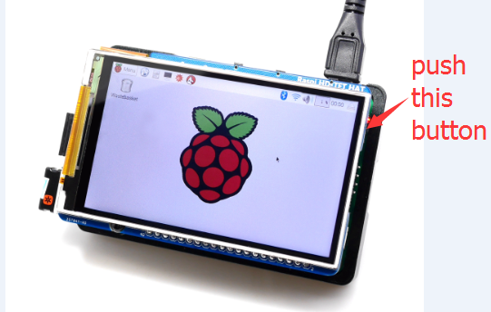

How to use 2 keys,like gpio
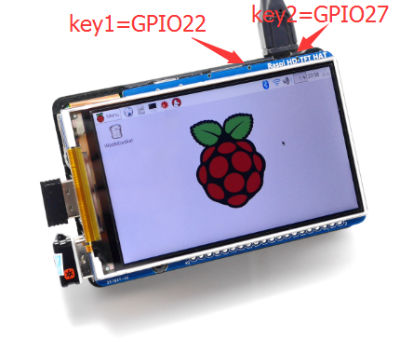

How to use the I2C master(I2C_3)
you can use this module by the following step

step 1.
Download the official firmware, then upgrade to the latest kernel
sudo rpi-update

step 2.
Config file to enable i2c_3
sudo nano /boot/config.txt

Add the following line:
dtoverlay=i2c-gpio,i2c_gpio_scl=24,i2c_gpio_sda=23framebuffer_height=480

step 3.
Make and install the pigpio
sudo git clone git://github.com/joan2937/pigpio
cd pigpio
sudo python setup.py install
sudo make
sudo make install

step 4.
install the I2C tools
sudo apt-get install i2c-tools python-smbus

step 5.
Config file to /etc/modules
sudo nano /etc/modules
Add the following line:
i2c-bcm2708
i2c-dev

step 5.
Config file to /etc/ rc.loacl
sudo nano /etc/ rc.loacl
Add the following line:
raspi-gpio set 23 pu
raspi-gpio set 24 pu

step 4.
Save then restart;

How to use the IR function:
Description:
- IR receiver function:
- Operating frequency: 38K HZ
- Receiving distance: 18-20m
- Reception angle: +/- 45 degrees
- The infrared transmitter function
- Wavelength: 940nm
- Transmitting distance: 7-8m
Preparation: Burn into raspbian system;
1. Start the Raspberry Pi, login Raspberry Pi through SSH, the user name: pi, default password: raspberry
2. Update and install lirc software, run the following command:
sudo apt-get update
sudo apt-get install lirc
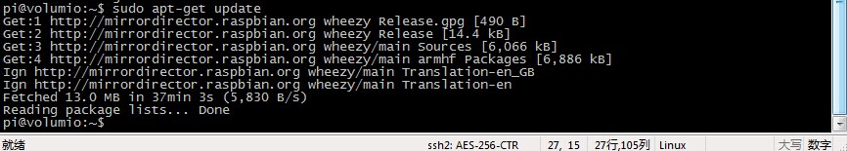
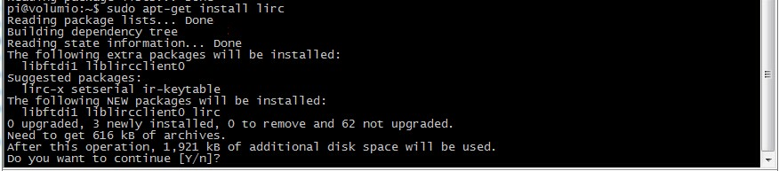
2. Edit the config.txt, and add configuration. use GPIO PIN 26;
sudo nano /boot/config.txt

Add the following line into the config.txt file:
dtoverlay=lirc-rpi, gpio_in_pin=26

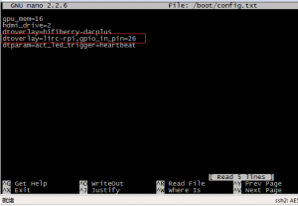

3. Edit LRIC config file to enable infrared function;
sudo nano /etc/lirc/hardware.conf

Modify the following lines:
LIRCD_ARGS=”--uinput”
DRIVER=”default”
DEVICE=”/dev/lirc0″
MODULES=”lirc_rpi”

4. Run "sudo reboot" to restart the Raspberry Pi, then run "ls / dev / l *" to view the infrared device is enabled
It's enabled if you can view the above red mark;
5.Record Button
sudo /etc/init.d/lirc stop
sudo irrecord -n -d /dev/lirc0 ~/lircd.conf

Record your IR remote control Follow the prompts, such as “pause”，“nextsong”，“prevsong”，“stop”，“volumeup”，“volumedown” etc.
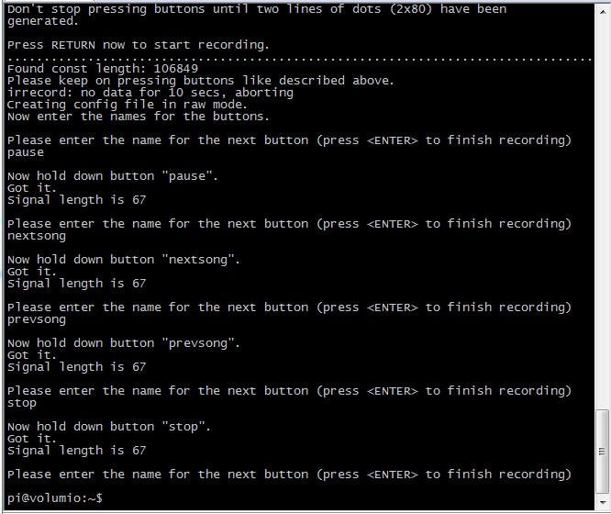
then you can get a lircd.conf file; override the old lircd.conf file;
sudo cp ~/lircd.conf /etc/lirc/lircd.conf

6. Startup lirc software;
sudo /etc/init.d/lirc start

7. Run the following command to view & check record result
sudo irw
Then press those record button;

8. You can view those button name to run irsend command;
irsend LIST /home/pi/lircd.conf “”
maybe it's following content:
irsend: 000000000000c837 pause
irsend: 00000000000048b7 nextsong
9. Now you can use the infrared transmitter, recorded before launching the remote control key coding, use that will extend the board as a rotary tool.Launch the command reference command:
irsend SEND_ONCE /home/pi/lircd.confpause
irsend SEND_ONCE /home/pi/lircd.confnextsong
irsend SEND_ONCE /home/pi/lircd.conf KEY_VOLUMEDOWN
irsend SEND_ONCE /home/pi/lircd.conf KEY_VOLUMEUP
Appendix:

1.LIRC http://www.lirc.org/
2. APP http://www.datscharf.dk/amote/

